

***DEPARTMENT OF COMPUTER SCIENCE ENGINEERING,***

***SCHOOL OF ENGINEERING AND TECHNOLOGY,***

***SHARDA UNIVERSITY, GREATER NOIDA***

**SMART IOT BASED PARKING SYSTEM**

***A project submitted***

***in partial fulfillment of the requirements for the degree of***

***Bachelor of Technology in Computer Science and Engineering***

**by**

**SUNNY RANA (2018011555)**

**SHAHID IMRAN (2018010028)**

**SHUBHAM MATHUR (2018006889)**

**Supervised by:**

**GUNJAN AGGARWAL, Assistant Professor**

**May, 2022**

**[i]**

**CERTIFICATE**

This is to certify that the report entitled “SMART IOT BASED PARKING SYSTEM” submitted by Mr. SUNNY RANA (2018011555), SHAHID IMRAN (2018010028), SHUBHAM MATHUR (2018006889) to Sharda University, towards the fulfillment of requirements of the degree of Bachelor of Technology is record of bonafide final year Project work carried out by him in the Department of Computer Science and Engineering, School of Engineering and Technology, Sharda University. The results/findings contained in this Project have not been submitted in part or full to any other University/Institute for award of any other Degree/Diploma.

Signature of Supervisor

Name:

Designation:

Signature of Head of Department

Name:

(Office seal)

Place:

Date:

# Signature of External Examiner

# Date:

**[ii]**

**ABSTRACT**

There has been a largescale growth in the number of vehicles plying on the road in past few years. But the existing road networks and road widths have not grown with respect to the increased vehicle number plying on the road. This has led to create huge parking crisis especially in urban areas. To tackle such intricate issues smart online parking systems are the need of the hour. This system aims to replace the conventional and existing parking system with an IoT-based smart parking system using RFID (radio-frequency identification). The users will be provided an RFID entry card for getting entry in the parking slot. The users will also be provided with an android based mobile application, through which they can get real time update and status of the availability of the parking slot on their mobile phones. Along with getting to know the real time availability of the parking slots the system also has the concept of detecting wrongly parked car within the parking area. In a parking area there are many areas which are either reserved or strictly no parking. Thus, the system here also uses the concepts of RFID to get the car detected. In this way, the proposed smart parking system will help in reducing human effort & time by using automation technology and making the system more efficient and smooth.

KEYWORDS: RFID, IR SENSORS.

**[iii]**

**ACKNOWLEDGEMENT**

A major project is a golden opportunity for learning and self-development. We consider our self very lucky and honored to have so many wonderful people lead us through in completion of this project. First and foremost we would like to thank Dr. Nitin Rakesh, HOD, CSE who gave us an opportunity to undertake this project. My grateful thanks to Assistant Prof. Mrs GUNJAN AGGARWAL for his guidance in our project work. “SMART IOT BASED PARKING SYSTEM” who in spite of being extraordinarily busy with academics, took time out to hear, guide and keep us on the correct path. We do not know where we would have been without his help. CSE department monitored our progress and arranged all facilities to make life easier. We choose this moment to acknowledge their contribution gratefully.

Name and signature of Students

SUNNY RANA (2018011555)

SHAHID IMRAN (2018010028)

SHUBHAM MATHUR (2018006889)

**[iv]**

**CONTENTS**

TITLE PAGE i

CERTIFICATE ii

ABSTRACT iii

ACKNOWLEDGEMENT iv

**[v]**

|  |  |  |
| --- | --- | --- |
| **Chapter 1** | **INTRODUCTION** | **9** |
|  | **1.1 PROJECT DESCRIPTION** | **9** |
|  | **1.2 PROBLEM DEFINATION** | **9** |
|  | **1.3 PROJECT OUTCOME** | **10** |
|  | **1.4 POSSIBLE RISK/DRAWBACK** | **10** |
| **Chapter 2** | **LITERATURE SURVEY** | **11** |
|  | **2.1 EXISTING SYSTEM** | **11** |
|  | **2.2 PROPOSED SYSTEM** | **11** |
|  | **2.3 LITERATURE SURVEY OF REFERRED PAPERS** | **12** |
| **Chapter 3** | **METHODOLOGY** | **15** |
|  | **3.1 SYSTEM COMPONENTS AND FUNCTIONALITIES** | **15** |
| **Chapter 4** | **DESIGN CRITERIA** | **19** |
|  | **4.1: SYSTEM DESIGN** | **19** |
|  | **4.2: SYSTEM ARCHITECTURE** | **20** |
| **Chapter 5** | **DEVELOPMENT & IMPLEMENTATION** | **21** |
|  | **5.1: DEVELOPMENTAL FEASIBILITY** | **21** |
|  | **5.2: WORK FLOW OF THE SYSTEM** | **21** |
|  | **5.3: SYSTEM WORKING** | **24** |
| **CHAPTER 6** | **RESULTS & TESTING** | **27** |
|  | **6.1: Result**  **6.1.1: Success cases**  **6.1.2: Failure cases** | **27** |
|  | **6.2: Testing**  **6.2.1: Type of testing adapted**  **6.2.2: Conclusion of Testing** | **30** |
|  | **6.3: Success of System** | **30** |
| **CHAPTER 7** | **CONCLUSION & FUTURE IMPROVEMENTS** | **31** |
|  | **7.1: CONCLUSION** | **31** |
|  | **7.2: LIMITATIONS** | **31** |
|  | **7.3: SCOPE OF IMPROVEMENT** | **31** |
| **References** |  | **32** |

**[vi]**

**LIST OF FIGURES**

FIGURE.1 LCD DISPLAY

FIGURE.2 RFID MODULE

FIGURE.3 GSM MODULE

FIGURE .4 ATMEGA 328 MCU

FIGURE.5 DC MOTOR

FIGURE .6 IR MODULE

FIGURE .7 ESP8266 WIFI MODULE

FIGURE .8 PARKING SYSTEM DESIGN

FIGURE .9 NO PARKING DETECTION SYSTEM DESIGN

FIGURE .10 SYSTEM ARCHITECTURE FOR SMART PARKING

FIGURE .11 WORKFLOW FOR ENTERING THE PARKING AREA

FIGURE .12 WORKFLOW DIAGRAM FOR DETECTION OF WRONGLY PARKED CAR

FIGURE.13 WORKFLOW DIAGRAM FOR THE DETECTION OF VACANT PARKING SPOTS

FIGURE .14 LCD DISPLAY OF THE PARKING SYSTEM

FIGURE 15. LCD CHECKING FOR THE EMPTY SLOTS IN THE PARKING

FIGURE 16. LCD DISPLAYING THE STATUS OF THE PARKING SLOTS

FIGURE 17. LCD DISPLAYING THE BALANCING CHECKING PHASE

FIGURE 18. SCREEN SHOWING CALLING MESSAGE

FIGURE 19. SYSTEM IN THE MONITORING PHASE

FIGURE .20 SETUP FOR THE PARKING MANAGEMENT SYSTEM

FIGURE .21 SETUP OF THE UNAUTHORIZED DETECTION SYSTEM

**[vii]**

FIGURE .22 APPLICATION VIEW SHOWING VACANT PARKING SPOTS

FIGURE .23 MESSAGE SHOWING SUCCESSFUL REGISTRATION OF THE USER

FIGURE .24 MESSAGE SHOWING AUTHORITY 2 BEING FINED FOR WRONGLY PARKED CAR

**[viii]**

**CHAPTER 1: INTRODUCTION**

Now days due to drastic increase in the population, there has been a tremendous increase on the cars plying on the road. This has also put a pressure on the cars getting proper parking. The existing parking management system includes extensive usage of man power and human intervention in order to provide the user with a proper parking. In this kind of system, a lot of time is wasted and the system is not quite effective and efficient. Along with this it has also been observed that in many parking areas the are some designated parking spots which are either reserved or are strictly marked as no parking, still some users park their cars in these spots which further increases the time, chaos and brings down the efficiency of the system. So, there is a need of developing a system that required less usage of man power and that can indicate directly the location of the parking spot along with all the necessary details related to the parking through a mobile. This system includes an RFID module, WIFI module, IR SENSORS that help in identifying and transmitting the information to the user. In areas where their are unauthorized parking a RFID receiver circuit will be placed. If a car gets parked in an unauthorized parking area, the RFID detector detects the car and sends an alert notification to the driver regarding the wrongly parked car.

**1.1 PROJECT DESCRIPTION**

The system aims to automate the entire process of parking and to have minimum human intervention so as to have smooth functioning. The system uses sensors like IR sensors, RFID modules, DC motor for automating the entire parking system and also has an additional feature of detecting a wrongly parked car in a parking lot.

**1.2 PROBLEM DEFINATION**

It has been noticed that the existing parking methods/system is largely dependent on human efforts and is less efficient in it working. Users have to manually search for a vacant parking spot which in itself is time taking and inefficient in nature. The users in their manual search either find a vacant spot or sometimes they park their cars in a no parking zone. This further intensifies the problem for the general public as this leads to unnecessary blocking of the traffic flow and also disrupts the plying of emergency vehicles. Seeing all these factors in mind, there is a need to automate the parking system so as to make it more efficient and user friendly. The proposed system includes a real time monitoring of the vacant spots in a parking lot, which the user can see prior to their visit. Along with this the entire system for the payment of the parking spot is also automated and done through RFID tags and module. The propose system also includes detection of wrongly parked car in the parking lot, that further helps to make the entire parking process smooth and error free.

**[9]**

**1.3 PROJECT OUTCOME**

The outcome of the project is the development of fully automated system that allows the user to searching for a parking spot and provides them with the parking spot without any human intervention. The system includes usage of sensors like IR sensors for the detection of the vacant parking spot, RFID module for the identification/registration/payment purposes related to the parking, WIFI module for transmitting the information gathered by the IR sensors to the online application through which the users can see and monitor the real time vacancy of any of the parking spot. The system also uses RFID module for the purpose of detection of illegally parked car in the parking lot.

**1.4 POSSIBLE RISK/DRAWBACK**

Some of the risks/drawbacks associated with the projects are:

1) The system efficiency largely depends upon the proper functioning of all hardware and software devices used, any failure of such device will bring down the efficiency of the system

2) The system lacks the option of increasing the parking time after the booking has been done

3) The system also depends on the honesty of the users who after booking must show up as the system may show that spot as reserved, if the user does not show up other commuters may face the issue of lack of parking spots

4) The system does not have the option of prior booking of the parking spots

**[10]**

**CHAPTER 2: LITERATURE SURVEY**

**2.1 EXISTING SYSTEM**

The existing system for parking includes the efforts that the user has to make in order to get a correct parking slot. This system includes a lot of human efforts and involvement of people to allot a parking slot in a parking. In this system, the user has to manually identify a vacant parking slot and along with it there is no provision to detect any wrongly parked cars. Many a times it has been noticed and user’s are unaware of the vacant spots status and this leads to confusion, traffic jams and wastage of time. For the detection of wrongly parked cars, human efforts are required in the existing system. People are deployed to keep a check on the cars to avoid illegal parking in unauthorized area in order to avoid traffic jams and to have a smooth functioning of the cars. The disadvantage of the system is that it requires usage of extensive manpower and is slow in its working. Keeping all this in mind, there is a need to automate the parking system.

**2.2 PROPOSED SYSTEM**

Now days in many public places such as supermarkets, offices, hospital area, market areas and shopping malls there is a significant problem of car parking. This creates a problem for the people and as well as for the authority to handle the crowd and to get their cars appropriately parked. So, there is a need of developing a labor saving system that indicates directly the location and the details of a vacant car parking slot in a parking area. This system includes an IR sensor that detects whether a parking slot is vacant or not. If vacant, the user on entry gets to see a green color parking slot on the screens placed in the parking area, where they can park their cars. The Esp8266 WIFI module helps the microcontroller to transmit the information procured by the IR sensors to the central system which in return displays and show real time monitored vacant parking slots on the screens placed in the parking area. The system also uses RFID tags to get the user information, there check in time/check out time and their balance in their RFID cards. The proposed system also has an additional feature to detect wrongly parked cars in an unauthorized area using the RFID transmitter that are placed in no parking areas within the parking. If a cars RFID tag comes in the range of such RFID transmitter, a message is sent to the respective car owner about the wrongly parked car through SIM 800A GSM module. Then the owners are given a time of 10 mins to move their car otherwise a fine is imposed on their card. During the checkout, the system calculates the charges for the user based on their check in/check out time which also includes any fine that may have imposed due to wrong parking.

**[11]**

**2.3 LITERATURE SURVEY OF REFERRED PAPERS**

In the study [1] the author here made a system that helped drivers to locate and reserve a parking place online through accessing it on web platform. The study included usage if Arduino and concepts of RFID for the detection of the vacant spot, along with that there is usage of MYSQL for the database management. The system had a major drawback that it did not show the drivers the number of parking spaces available and did not allow the drivers to book a specific parking spot. [2] This study is based on the purpose to increase efficiency of the current parking system, track the nearest parking space available through the help of a router, and book the available parking space. The system uses ESP8266 controller and RFID modules, IR sensors for the detection of the vacant parking spots. This system did show the available number of parking spaces but did not send the reminder to the drivers a message to avail the parking spot. This system also did not have the facility to show the users live tracking of the parking spaces. [3] This study allows the user to access a web application/mobile application to book their parking spots in advance. This system uses Arduino board to detect vacant spots for parking and to interact with the cloud to share this information to the user via the mobile application. Through the application, the user can book the slot in advance prior to their visit. The system uses ARDUINO, GSM module, NODE MCU, servo motors and for the database it used MS SQL server. The disadvantage of this system is that with increase in the user number, the system tends to get slow. [4] This system provides with both mobile app and a website to book the parking slot. The user can book the slot prior and can pay for the parking using the in buil payment feature that is made available in the application. The system uses IR sensors and NODE MCU for the detection of the vacant spot and to transfer the information received to their application. The system also provides with an option of cancelling the booking or to extend the stay time. One disadvantage that the system has is that the failure of IR sensors leads to the failure of the entire system. [5] The proposed system integrates RFID and WSN technologies to provide advanced features and services for car parking management. It uses an active RFID tag per vehicle. The tag can be allocated to a subscribed customers over a long period of time (private parks), or it can be dynamically provided to the transient customers at the entrance. The system uses RFID module, servo motor, WSN application for the detection and allocation of the parking spot. The main advantage of the system is its low cost and simplicity over parking lot management. One disadvantage that the system has is that there is no driver guidance systems to guide the driver towards the parking spot. [6] This system includes the usage of Bluetooth, LCD (Liquid Crystal Display), ARM Cortex M3, Rack and pinion for its parking management. The system uses the user mobile’s Bluetooth for identification and registration. The vehicle is transported to the parking location with the help of a rack and pinion mechanism for linear motion. Then the system automatically detects the unique registration number stored in the Bluetooth chip to check if the new vehicle is to be parked or not. The advantage of the system is that it eliminates the need for additional parking tokens, as every Bluetooth has a unique registration number so the system is free from redundancy. Though the system is costly and the range of the Bluetooth causes range issues. [7] The system uses RFID module, Zigbee, WSN, MCU lPC2148 and led display. The sensor network carries all information about the parking space from the sensor node to management center via Zigbee. This helps in the detection of the vacant parking slots and this information is further transmitted to the user through a mobile application. The system take more time during the node to node transfer of the information and its efficiency falls when the number of the users increase. [8] the author here studied about the system that consisted of RFID module, GSM modem, Infrared Sensor module, Servo motor, Arduino UNO, Arduino Mega. Here, it did not matter whether a vehicle had an RFID tag or not, as data of vehicles having no RFID tags will be verified in the particular RTO’S. The future scope involves fine and parking fee collection via e-payment and parking slot booking in advance via SMS. [9] It is based on 5 major processes Background Modelling, 1-D Projection, Segmentation, Tracking, Reconstruction. It presents a way for detecting the phenomena in real time by applying a novel image projection that reduces the dimension of the data and, thus, reduces the complexity of the segmentation and tracking processes.[10] In addition of detecting the vehicles which are falsely parked and imposing a fine on them this work allows us to book a parking slot in advance. It also presents the present number of cars, jeep, buses, and all other vehicles in the parking on the LCD. Future scope includes The Database has all the information stored related such as: type of the vehicle, model of the vehicle, registration number of the vehicle, the availability of space in the parking is also shown in the LCD.

**[12]**

**[13]**

[11] It reads the vehicle id and checks whether its registered or not if it is registered then it further checks the database for the check-in time and opens the gate and updates the checkout info. If the vehicle is not registered the system will not open the gate. [12] This work checks whether a vehicle is parked at no parking area or not by reading RFID tag and if a vehicle is parked in that no parking area for more than 10 sec the buzzer will ring. If the vehicle is still there after the buzzer rang the particular information of the vehicle will be sent to the nearest police station and a fine will be imposed to the owner. [13] This work works on the principle that a RFID transmitter is fitted in no parking zone. whenever a car parks in the no parking zone the transmitter receives the signal and fines the driver. It has high accuracy, does real time monitoring and is easy to use. future scope may include sending the data of the driver to the authorities and doing online fine payments [14] The work works on the principle that a proximity sensor is fitted in the no parking area so as to detect the presence of any car. Along with it, a PIR sensor is also fitted to detect the presence of the driver. once the proximity sensor detects the car, it sends data to the nearby authority. The work requires less human intervention and helps in clearing the congestion on roads. Its future scope includes capturing the image of the car and using inductive proximity sensor to detect metal.[15] The work is divided into 2 parts. first is the parking entry where through RFID the details of the driver and of the car are collected. second part includes the parking management system, it helps in detecting a vacant spot using an ultrasonic sensor and also uses ultrasonic sensors to detect wrongly parked cars. its future scope includes of expanding the work in small area of the city. [16] The work works on the principle that an IR sensor is fitted in the areas where parking is prohibited, if a car gets parked there, the system alerts the driver and gives them a timer of 5 mins, if even after 5 mins the car is not moved, the system fines the driver based on the information received through the RFID transmitter. in future the work aims to include the system to alert the authorities for further action.

**[14]**

**CHAPTER 3: METHODOLOGY**

**3.1 SYSTEM COMPONENTS AND FUNCTIONALITIES**

A. LIQUID CRYSTAL DISPLAYs (LCD)

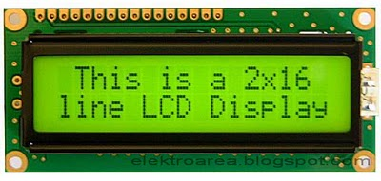

Figure.1 LCD display

The 16x2 display LCD is one of the most used LCDs that are integrated to the microcontrollers. This simply means 20 characters per line by 2 lines and 16 characters per line by 2 lines and, respectively. The standard is referred to as HD44780U, which communicates directly with the LCD and indicates to the controller chip which receives data from an external source.

B. RFID READER

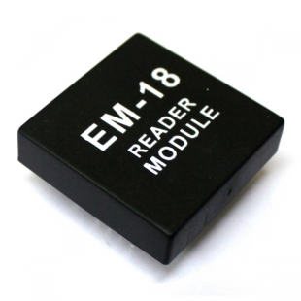

Figure.2 RFID module

From ID Innovations, this is a very simple to use RFID reader module. The only holdup is the 2mm pin spacing with a build in antenna. Powering up of the module, keeping up a card, and getting a serial string output containing the particular identity of the card.

**[15]**

C.GSM MODULE

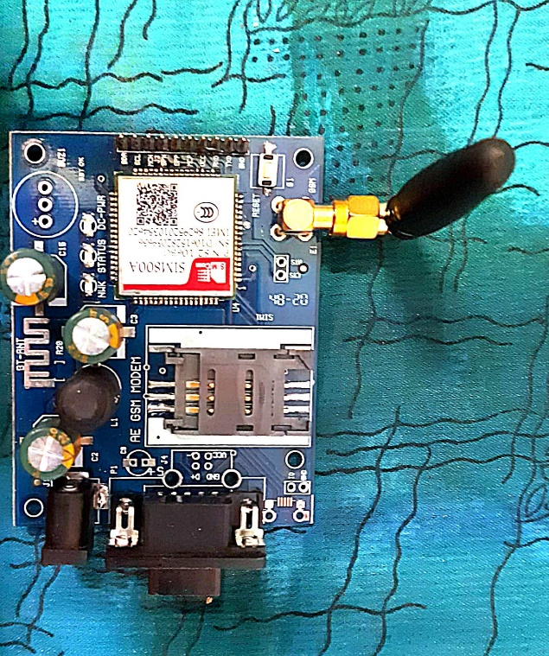

Figure.3 GSM module

SIM 800A is a Tri band GSM/GPRS engine that works on various frequencies like 900MHz, 1900MHz, and DCS 1800. With configuration of 40mmx33mmx2.9mm, SIM 800A can meet almost all the space requirements like in smart phone, PDA phone and other devices. The physical interface provides all hardware interfaces between the module and customers’ boards and the RF antenna that interfaces to the mobile application is a 60 pins board t board connector.

D. ATMEGA 328

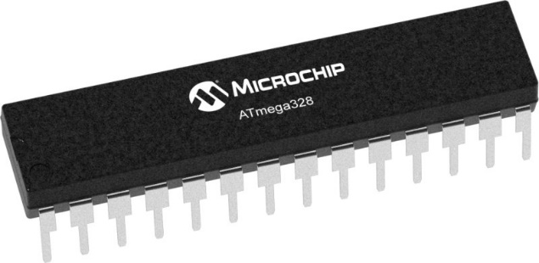

Figure .4 ATMEGA 328 MCU

**[16]**

The Atmel eight-bit AVR RISC-based totally microcontroller combines 32 KB ISP flash reminiscence with read-at the same time as-write talents, 1 KB EEPROM, 2 KB Static Random Access Memory, 23 widespread-reason I/O traces,32 general cause working registers.ATmega328 is normally used in many areas and [autonomous systems](https://en.wikipedia.org/wiki/Autonomous_systems) where a simple, low-powered, low-cost micro-controller is needed. Perhaps the most common implementation of this chip is on the popular [Arduino](https://en.wikipedia.org/wiki/Arduino) development platform, namely the [Arduino Uno](https://en.wikipedia.org/wiki/Arduino_Uno) and [Arduino Nano](https://en.wikipedia.org/wiki/Arduino_Nano) models.

E. DC MOTOR

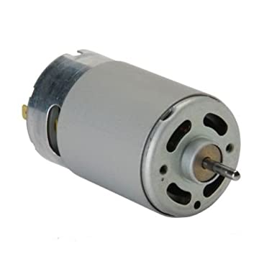

Figure.5 DC motor

A DC motor is one of the types of rotary [electrical motors](https://en.wikipedia.org/wiki/Electrical_motor) that converts direct current electrical energy into mechanical energy. The most common types rely on the forces produced by magnetic fields. DC motors use magnetic fields that occur from the electrical currents generated, which powers the movement of a rotor fixed within the output shaft. The output torque and speed depend upon both the electrical input and the design of the motor.

F. INFRARED SENSOR

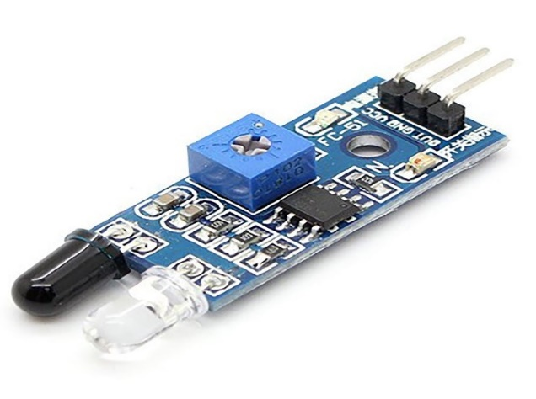

Figure .6 IR module

**[17]**

An infrared sensor is an electronic device, that emits in order to sense some aspects of the surroundings. An IR sensor can measure the heat of an object as well as detects the motion. These types of sensors measure only infrared radiation. Once the infrared transmitter generates emission, then it arrives at the object & some of the emission will reflect back toward the infrared receiver. The sensor output can be decided by the IR receiver depending on the intensity of the response.

G. ESP8266 WIFI MODULE

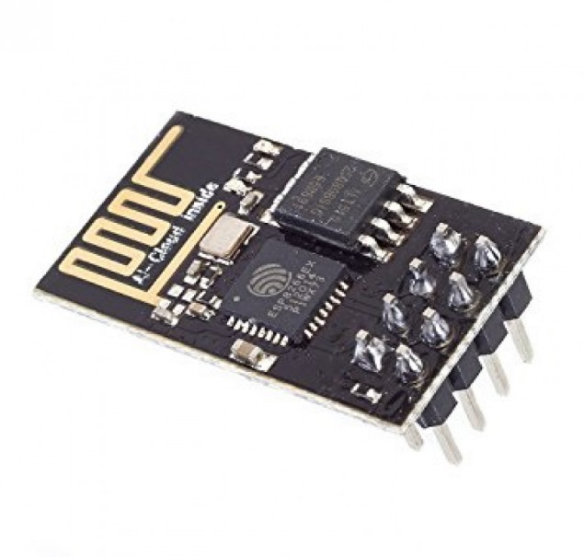

Figure .7 ESP8266 WIFI module

The ESP8266 MODULE is a low cost WIFI microchip, with built in TCP/IP networking software and microcontroller capabilities. This small module allows microcontrollers to connect to a WIFI network and make simple TCP/IP connection

**[18]**

**CHAPTER-4: DESIGN CRITERIA**

**4.1: SYSTEM DESIGN**

motor

ATmega328p

RFID

IR sensors

LCD display

IoT

Figure .8 Parking system Design

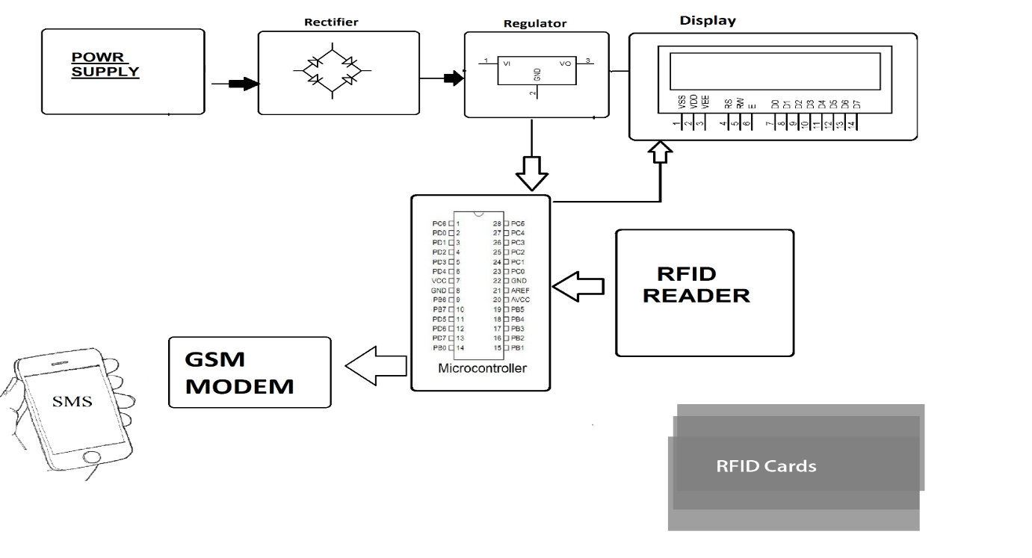

Figure .9 No Parking Detection System Design

**[19]**

**4.2: SYSTEM ARCHITECTURE**

EXIT GATE

IIRIR SENSORS

SSERVO MOTOR

EEND USERS

P

SPOWER SUPPLY

AATMEGA 328p

Figure .10 SYSTEM ARCHITECTURE FOR SMART PARKING

NNODE MCU

Esp8266

ISERVO MOTOR

IIR SENSOR

ENTRY GATE

IIR SESNOR 4

IIR SENSOR 3

IR SENSOR 2

IIR SENSOR 1

PARKING

LED LIGHT

=LCD SCREEN

**[20]**

**CHAPTER-5: DEVELOPMENT & IMPLEMENTATION**

**5.1: DEVELOPMENTAL FEASIBILITY**

For the development of the project following objectives were set:

1) easy and efficient parking system

2) detection of unauthorized parking

3) prior view of parking to the user

All the above objectives were successfully achieved and the project after development had Technical, Operational and Economical feasibility.

**5.2: WORK FLOW OF THE SYSTEM**

DDETECTION OF RFID

IF BALANCE < 0

DGATES DO NOT OPEN

SSYSTEM CHECKS THE BALANCE IN THE RFID CARD

IF BALANCE > 0

DDTHE GATES AUTOMATICALLY OPEN AND THE VEHICLE ENTERS

HTHE VEHICLE GETS PARKED IN THE VACANT SPOT

Figure .11 WORKFLOW FOR ENTERING THE PARKING AREA

**[21]**

The system starts by the detecting the RFID tag, once the detection is done, the system checks its balance. If the balance > 0, the automatic doors are opened and if the balance < 0 then the doors are not opened. Once the car enters the parking spot, it is directed towards the vacant spots through the screens showing the position and status of the vacant spots.

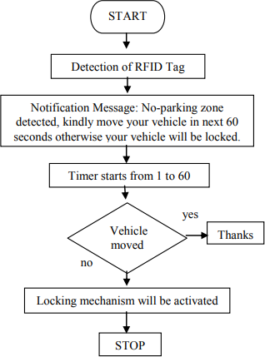

A message that the driver has been fined is sent to the driver

No fine is imposed

If the car is parked in a no parking zone, the RFID receiver detects the car and a message is sent to the driver about wrong parking

Figure .12 WORKFLOW DIAGRAM FOR DETECTION OF WRONGLY PARKED CAR

The system starts by the detecting a wrongly parked car through the RFID system, if the car is moved then no fine is imposed on the driver, but if the car remains parked in the no parking zone the system automatically fines the driver and a message is sent to the driver regarding the fine being imposed for the unauthorized parking

**[22]**

IF SLOT FILLED

DIR SENSOR DETECTS IF CAR IS PARKED IN FRONT OF IT OR NOT

THE SENSOR TRANSMITS THIS INFORMATION AND THE MCU SHOWS THE SPOT AS FILLED

IF SLOT EMPTY

THE IR SENSOR TRANSMITS THIS INFORMATION THROUGH THE ATMEGA MCU AND THE VACANT SLOT IS DISPLAYED ON THE SCREEN AND USER PARK THEIR CAR

Figure.13 WORKFLOW DIAGRAM FOR THE DETECTION OF VACANT PARKING SPOTS

The IR sensors detect whether a car is parked in front of them or not. through that the get the information regarding a vacant spot. Then this information is transmitted gathered by the ATMEGA MCU and is then transmitted through the WIFI module to the screens so as to notify the drivers regarding the availability of vacant spots

**[23]**

**5.3: SYSTEM WORKING**

**A) FOR THE PARKING**

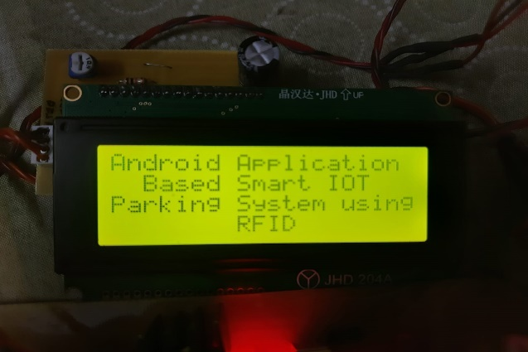

Figure .14 LCD display of the parking system

The system starts by the user first checking the status of the parking spots on the mobile/web application provided. Based on the status received through the system to the user, the user can identify whether any parking spot is vacant or not

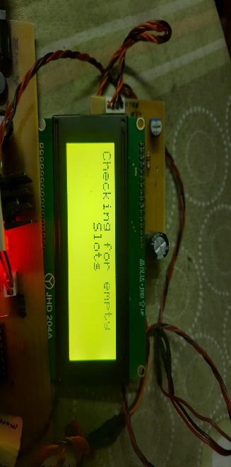

Figure 15. LCD checking for the empty slots in the parking

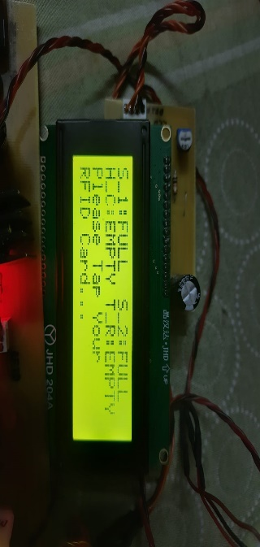

Figure 16. LCD displaying the status of the parking slots

The system through its IR sensors checks whether the parking spots are vacant or not. it then conveys the same information to the user using the mobile/web application. On reaching the parking lot, the system first scans the RFID tag to identify the user. Once identified, the system then checks the balance money present in the user’s RFID tag.

**[24]**

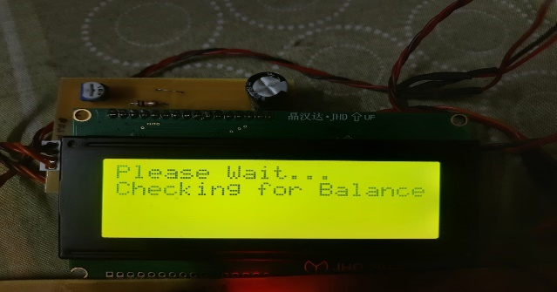

Figure 17. LCD displaying the balancing checking phase

If the amount is zero then the gates won’t open else the IR sensor detects the car and once the balance confirmation is received, the gates are automatically opened and a “welcome” message is displayed on the screen Once the user entre the parking lot, their check in time is noted and the user parks the car in the allotted vacant spot. While exiting, the RFID tags present in the exit gates once again detect the user and determine their check out time. The system also checks if any penalty is also imposed on the user for the wrongly parked car. Through this their total time in the parking lot and their penalty is calculated and while exiting, the respective amount is automatically deducted from there RFID tag balance

**B) FOR THE DETECTION OF WRONGLY PARKED CAR**

The system starts with the user registering to the system for once through the GSM module. The user has to give a call to the sim number that is being used in the corresponding GSM module.

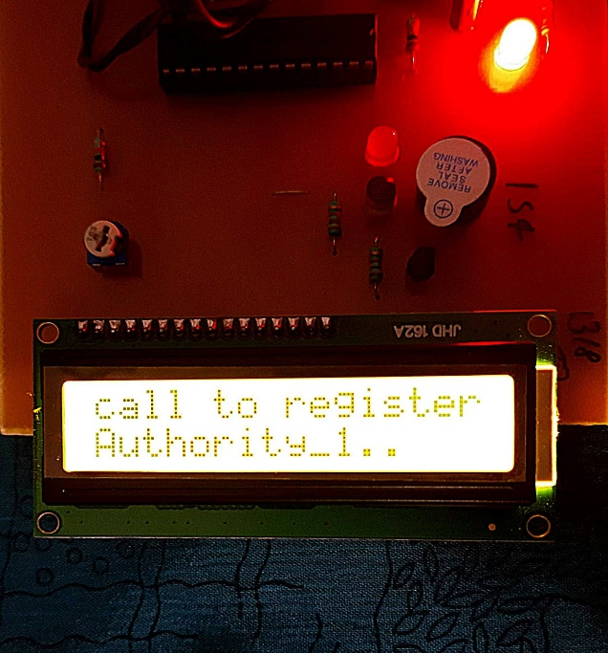

Figure 18. Screen showing calling message

**[25]**

Once the user has given the call, a unique RFID card is swiped that is unique to the user and it resembles the user itself. The system is having the capacity to handle two authorities at one time. Once a unique RFID card has been allotted to the user, a message is sent to the user stating ‘you have been registered as authority 1’. Once both the authorities are registered and each have got a unique RFID card, the system then goes to the monitoring stage,

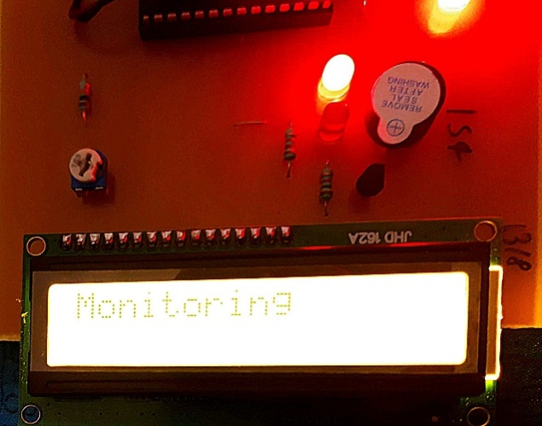

Figure 19. System in the Monitoring Phase

In the monitoring phase, if any car is parked in an unauthorized parking, the system detects the car, scans the RFID tag and a message is sent to driver regarding the wrongly parked car. If the driver does not move their car, a fine is automatically imposed on the driver for the wrong parking and this fine in the later stage is added to the parking amount as a grand total.

**[26]**

**CHATPER-6: RESULTS & TESTING**

**6.1: Result**

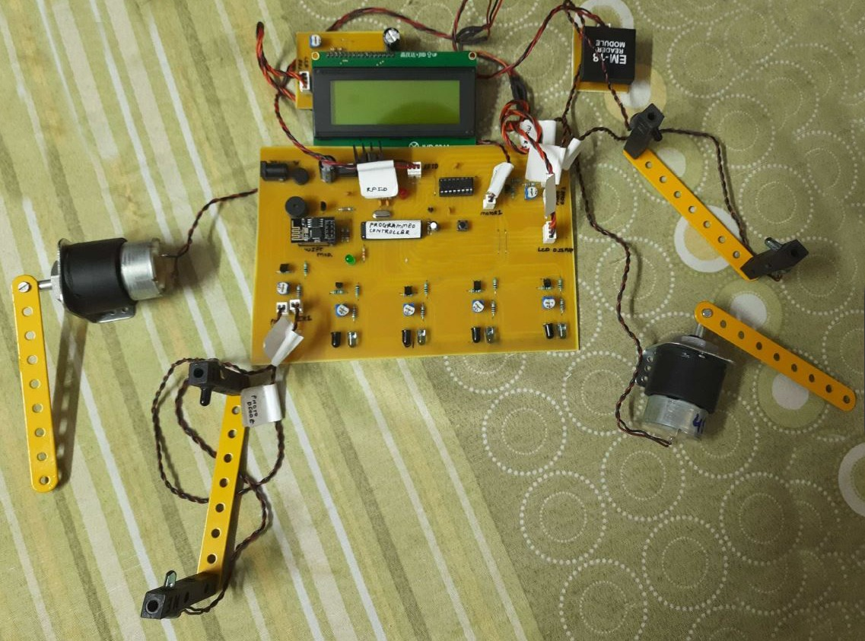

Figure .20 SETUP FOR THE PARKING MANAGEMENT SYSTEM

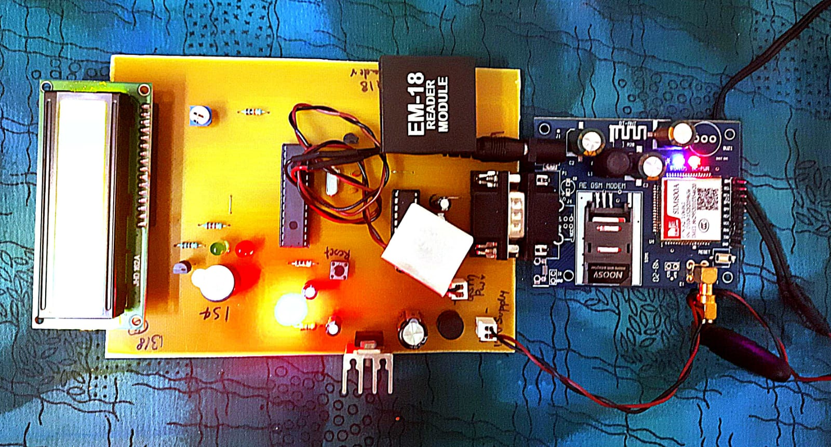

Figure .21 SETUP OF THE UNAUTHORIZED DETECTION SYSTEM

**[27]**

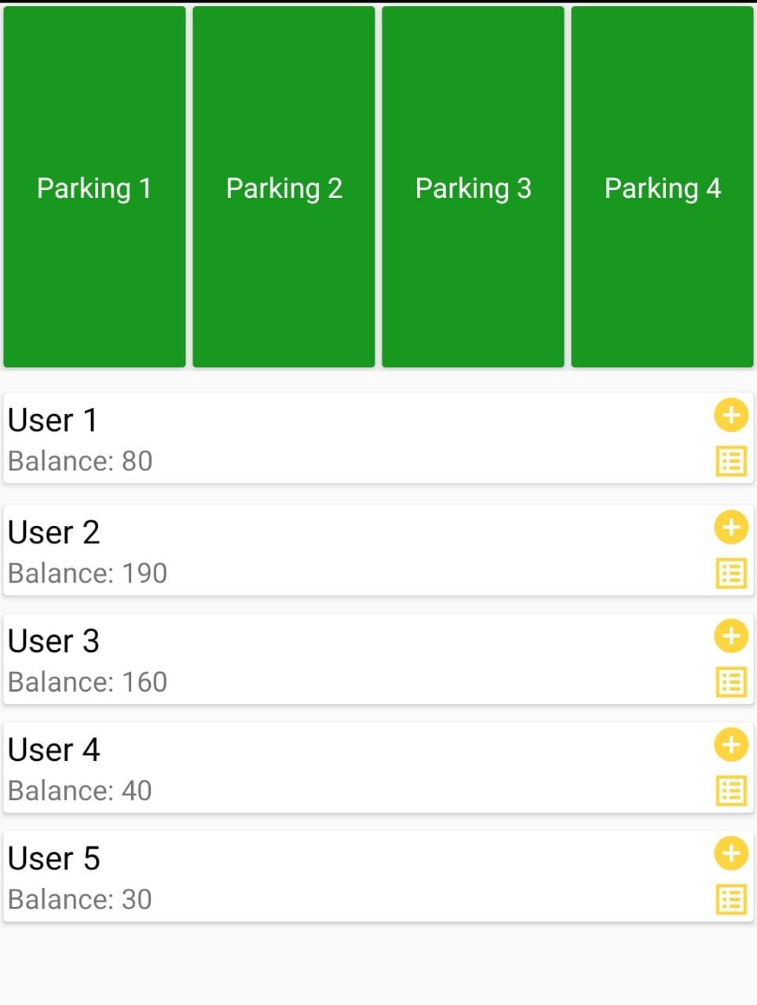

Figure .22 APPLICATION VIEW SHOWING VACANT PARKING SPOTS

**[28]**

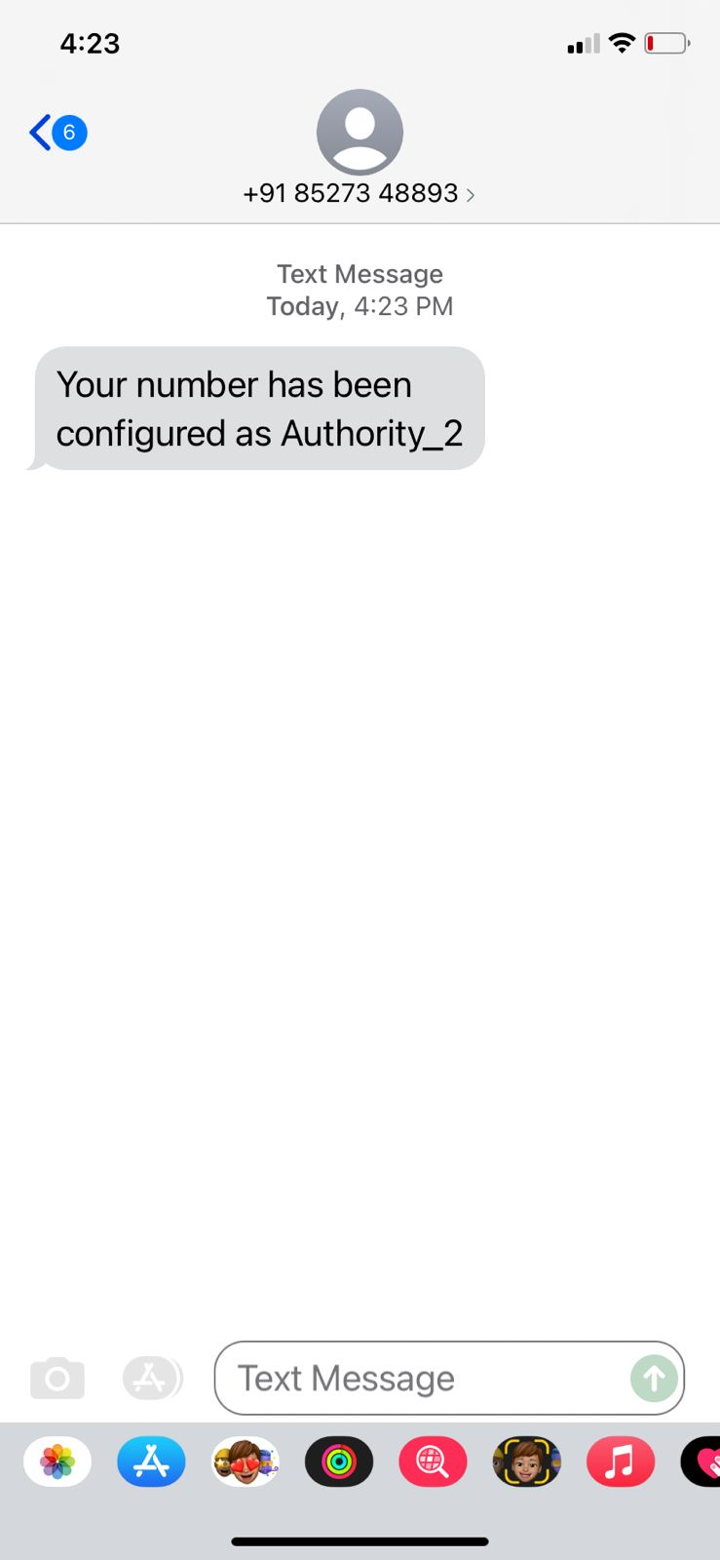

Figure .23 MESSAGE SHOWING SUCCESSFUL REGISTRATION OF THE USER

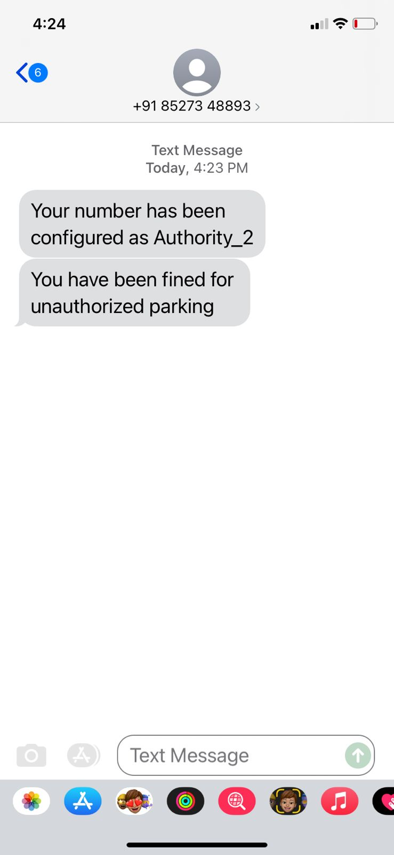

Figure .24 MESSAGE SHOWING AUTHORITY 2 BEING FINED FOR WRONGLY PARKED CAR

**[29]**

**6.1.1: Success cases**

While testing of the developed system, the system performed efficiently and all the inputs provided had the required output. The system achieved its primary goal of automating the parking system and to create a management system that is efficient and smooth in its functioning.

**6.1.2: Failure cases**

The system only tends to fail/ perform its primary function when either of the IOT sensors/device (IR sensor, RFID module, DC motor, LCD screen) tends to fail in there functioning**.** The system encounters certain lag time to update the vacant parking spot status in the application depending upon the internet speed.

**6.2: Testing**

**6.2.1: Type of testing adapted**

1) Usability testing

2) Reliability and Scalability testing

3) Performance testing

**6.2.2: Conclusion of Testing**

After the conduction of the above mention testing’s, the system performed perfectly for all the tests and achieved its goal without any compromise in user’s security, performance and reliability of the system. All the tests conducted were successful in nature

**6.3: Success of System**

The system is able to achieve all the pre set goals and objectives and all the user requirements of a safe, secured, smooth and efficient automated parking system are met to the maximum extent

**[30]**

**CHAPTER-7: CONCLUSION & FUTURE IMPROVEMENTS**

**7.1: CONCLUSION**

The system aims to reduce the issue of parking management and unauthorized parking using automatic techniques in order to reduce the human efforts and to improve the efficiency of the entire system using the modern technology. All these issues have been addressed by our proposed system that works with the aim to improve the conventional method adopted for the parking management and to tackle the issue of unauthorized parking in the parking lots. Through the system, regular monitoring can be achieved with minimum human intervention and more effective results can be obtained. The system in the future may incorporate methods to cancel and to extend the booking time for a particular parking spot.

**7.2: LIMITATIONS**

Certain limitations associated with the system are as follow:

1) The parking slots are limited to 4 for the current system

2) The range of the RFID module is limited

3) There is a certain time lag in the updating of the status of the vacant parking spots in the application

**7.3: SCOPE OF IMPROVEMENT**

Below mentioned are some of the future scope associated with the developed system:

1) Addition of the feature of prior booking of the slots by the user

2) Addition of the feature of extending the parking booking time

**[31]**

3) Giving 10 mins buffer time to the user for unauthorized parking before the fine is imposed

4) Better and more smooth functioning of the application for faster and more efficient updating of the parking status

5) Increasing the range of RFID module for better functioning

**REFERENCES**

**[32]**

|  |  |
| --- | --- |
| S.no | AUTHOR |
| [1] | Ndayisaba Corneille , Rohit Diwakar, “ ONLINE VEHICLE PARKING RESERVATION SYSTEM”, IJESC, ISSN 2321-3361, VOL-10,ISSUE-5 , 2020 |
| [2] | Amol Pomaji, Suraj Boinwad, Shrikant Wankhede , Pushpendra Singh , Bhagyashree Dhakulkar, “Smart Parking Management System”, ISSN 2249-8958,VOL-8,ISSUE-5 JUNE 2019 |
| [3] | Amira. Elsonbaty and Mahmoud Shams, “SMART CAR PARKING MANAGEMENT SYSTEM USING RFID”, , IEEE AUG 2019 |
| [4] | Supreeth Y S, S G Raghavendra Prasad and Dr. Jitendranath Mungara, “Smart Parking System for Smart Cities”, IEEE XPLORE |
| [5] | El Mouatezbillah Karbab, Djamel Djenouri, SaharBoulkabol, Antoine Bagula, “Car Park Management with Networked Wireless Sensors and Active RFID”, ISN : 2320-8945 , VOL 1 , ISSUE-2,2013 |
| [6] | Harmeet Singh, Chetan Anand, Vinay Kumar, Ankit Sharma, “Automated Parking System with Bluetooth access”, , IJARSE VOL-7, APR 2018 |
| [7] | M. M. Rashid, A. Musa, M. AtaurRahman, N. Farahana, “Automatic Parking Management System and Parking Fee Collection Based on Number Plate Recognition”, 9th International (pp. 639-643). IEEE.2015 |
| [8] | Manjusha Patil, Vasant N. Bhonge, “Wireless Sensor Network and RFID for Smart Parking System”, IJEAT,ISSN-22498958 VOL-9 ,ISSUE-2, DEC 2019 |
| [9] | Ishraq Haider Chowdhury, AfsanaAbida, Md. Mehedi Hasan Muaz Automated Vehicle Parking System And Unauthorized Parking Detector |
| [10] | Jong T. Lee, M. S. Ryoo, Matthew Riley, J. K. Aggarwal Real-Time Illegal Parking Detection in Outdoor Environments , IEEE AUG 2019 |
| [11] | S. C. Hanche, Pooja Munot, PranaliBagal, Kirti Sonawane& Pooja Pise Automated Vehicle Parking System using RFID , ISN : 2320-8945 , VOL 1 , ISSUE-2,2013 |
| [12] | ZeydinPALA , Nihat inanSMART PARKING APPLICATION USING RFID , IEEE XPLORE |
| [13] | Murthy D. A ,Manjunath A ,MadhusudhanP,WarshaBalani , DESIGN AND DEVELOPMENT OF NO PARKING SYSTEM , IJARSE VOL-7, APR 2018 |
| [14] | C. George Christopher, J. Vidhya Unauthorized Vehicle Parking Detection and Auto-Locking using an Arduino, IJEAT,ISSN-22498958 VOL-9 ,ISSUE-2, DEC 2019 |
| [15] | M Manoj Prabhu, R Jayaraj, R Karthikeyan Automatic Unauthorized Parking Detector  IJEAT , ISSN 2249-8958,VOL-8,ISSUE-5 JUNE 2019 |
| [16] | Ankita Gupta, Ankit Srivastava, Rohit Anand Smart vehicle parking monitoring system using RFID  IJITEEE , ISSN 2278-3075, VOL-8, ISSUE-9,JULY 2019 |
| [17] | M.Indumathy , A. Arun Reddy , K. Jitender Reddy Avoidance of unauthorised vehicle parking IJESC, ISSN 2321-3361, VOL-10,ISSUE-5 , 2020 |
| [18] | J. Cynthia, C. B. IOT based Smart Parking Management System. International Journal of Recent Technology and Engineering (IJRTE), 2018 |
| [19] | Asghar Ali Shah, G. M,. Video Stitching with Localized 360 Model for Intelligent Car Parking Monitoring and Assistance System . IJCSNS International Journal of Computer Science and Network Security.2019 |
| [20] | Rico, J., Sancho, J., Cendon, B., & Camus, M. Parking easier by using context information of a smart city: Enabling fast search and management of parking resources. In Advanced Information Networking and Applications Workshops (WAINA), 2013 27th International Conference on (pp. 1380-1385). IEEE. 2018 |
| [21] | Ji, Z., Ganchev, I., O'droma, M., & Zhang, X. A cloud based intelligent car parking services for smart cities. In General Assembly and Scientific Symposium (URSI GASS), XXXIth URSI (pp. 1-4). IEEE.2014 |
| [22] | Chen, S. Y., Lai, C. F., Huang, Y. M., & Jeng, Y. L. Intelligent home-appliance recognition over IoT cloud network. In Wireless Communications and Mobile Computing Conference (IWCMC), 9th International (pp. 639-643). IEEE.2015  **[33]** |
| [23] | R. H. Giva Andriana, Anak Agung, “Sensor Comparation for Smart Parking System,” pp. 4–9, 2012. |
| [24] | S. A. El-seoud, H. El-sofany, and I. Taj-eddine, “Towards the Development of Smart Parking System using Arduino and Web Technologies,” no. 978, pp. 10–16, 2016. |

**[34]**